Copyright reserved

Please turn over

**NATIONAL CERTIFICATE**

**MECHANOTECHNICS N4**

**JULY 2019**

**30**

**This marking guideline consists of 8 pages.**



**MARKING GUIDELINE**

NOTE: √ = ½ mark

✓ = 1 mark

# QUESTION 1

1.1 Workshop layout is the arrangement, storage and planning of different

elements of a workshop. (3)

1.2 • Storage facilities

* Supply of services • Transport routes and aisles
* Handling of workpieces • Carrying capacity of the floor • Space around and above each machine (Any 5 × 1) (5)

1.3 Excessive paint spray (1)

* The viscosity of the paint is too low.
* The atomising air pressure is too high.
* The distance between the spray gun and the workpiece is too great.

(Any TWO) (2)

Uneven spray-painting (1)

* There is insufficient air pressure.
* The spray nozzle is no longer effective because of obstructions, damage or a faulty adjustment.
* Blocked pipes reduce the paint supply. (Any TWO) (2)

Sagging surface (1)

* The spray gun moves too slowly.
* Too much paint is applied to the surface.
* The spray gun is held too close to the surface.
* The paint is too thin. (Any TWO) (2)

Speckle or orange-peel effect (1) • Wrong thinners or solvents are used.

* Paint is not mixed properly before use.
* Surface is prepared incorrectly.
* The air pressure is wrong. (Any TWO) (2)

1.4 • Minimal frictional resistance

* Strength
* Resistance to wear
* Thermal conductivity • Resistance to corrosion (5)

-2-

1.5

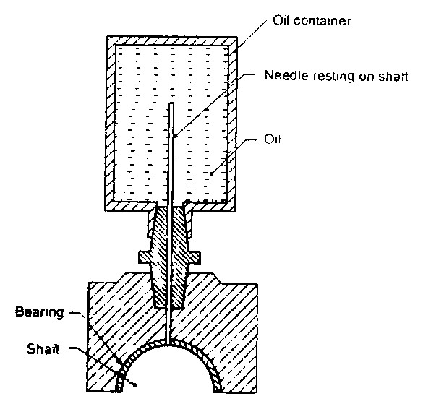

Shaft

Oil container

Needle resting on shaft

Oil

Bearing

(5)

**[30]**

# QUESTION 2

2.1 π(*D* +*t N*) *v* =

60 π(0,6 + 0,02)× 600

= ✓

60

=19,478 *ms*/ ✓

*TC* = *mv*2

= 0,5(19,478)2

=189,696 *N* ✓ (3)

2.2 *T*1 =σ. .*wt*

= 4 ×106 ×0,155×0,02 ✓

=12 400*N*✓ (2)

2.3 *T T*1 − *C* µθ

=*e*

*T T*2 − *C*

12400 −189,696 0,2 2,792×

=*e* ✓

*T*2 −189,696

12210,304

=1,747✓

*T*2 −189,696

12210,304 =1,747*T*2 −331,398✓

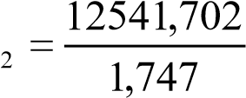  *T*✓

∴ =*T*2 7178,994*N* ✓ (5)

2.4 *P* = −(*T*1 *T v*2)

= (12 400 − 7178,994)19,478✓

=101694,755*W*✓ (2)

2.5 *Po*

*Pi* =  η

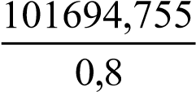 *Pi* =✓

=127118,444*W* ✓ (2)

**[14]**

# QUESTION 3

3.1 3.1.1 *Cutting Area* = *Feed* /Re*v*×*Cutting depth*

= 0,5×3,5

=1,75 *mm*2✓

*F* = *P*× *A*

=1000 1,75×

=1750*N*✓ *v* =π. .*D N*

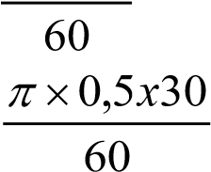

=

= 0,785 *m s*/ ✓

*P* = *F* ×*v*

*o*

=1750×0,785

=1374,446*W* ✓ (4)

3.1.2 *Po*

*P* =

*i* η

## *Pi* =✓✓

=1616,996*W*✓ (3)

3.2 3.2.1 *Ff*  µ=

*N R*

*f*

*F* =µ×*N*

*R*

= 0,07×200×9,81✓✓

=137,34*N*✓ (3)

3.2.2 *Ff*

µ=

*N R*

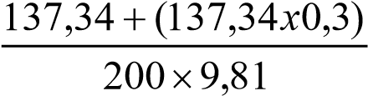

## µ=✓✓

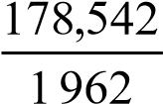 µ=✓

= 0,091✓ (4)

**[14]**

# QUESTION 4

4.1 4.1.1 *m*

*C* = (*TA* −*TB* )

2

 45 =(*TA* + 30)✓

90 =1,5*TA* − 45) ✓

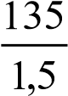

*TA* =

= 90 *teeth*✓

4.1.2 *PCDA* =*mxTA*

=1,5×90✓✓

=135 *mm*✓

(2 × 3) (6)

|  |  |  |  |
| --- | --- | --- | --- |
| **CONDITION** | **PINION A** | **GEAR WHEEL B** | **ARM C** |
| *Fix arm C and rotate gear B by +1 rev* |  | =+1√ | *0* √ |
| *Multiply by x and add y* |  | *x y*+ √ | + *y* √ |
| *NA* = ?  *NB* = 0*r* / min  *NC* = | *NA* = ?√ | *NB* = 0√ | *NC* =+100√ |

4.2

|  |  |
| --- | --- |
| *x y*+ = 0.........1 *y* =100........2  *Substitute* ...2 *in* ....1 *x* =−*y* √ *x* =−100✓  *NA* =− +4*x y*  *NA* =− −4( 100) +100✓ | (8) |
| *NA* =+500 *r*/min *clockwise*✓ |

**[14]**

# QUESTION 5

**A**

5.1

55

,

13

**E F**

60°

**B**

**C**

**D**

25

,

70

35

30

°

*AD AB BC*= + +*CD*

*AB* = *r*

*r*

tan30°=

*BC*  *r*

0,577 =

*BC*

*BC* =1,732*r*

*CD* = 55,13−*EF*

35 tan60°=

*EF*

35  *EF* = ✓ tan60°

*EF* = 20,207 ✓

*CD* = 55,13− 20,207

*CD* = 34,923

*AD* = *AB* + *BC* +*CD*

70,25 = +*r* 1,732 + 34,923

35,327 = 2,732*r*✓

|  |  |
| --- | --- |
| *r* =12,931✓  *D* = 25,862 *mm*✓ | (7) |

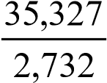  *r* =

5.2

X

40°

Ø15

**A B**

110

*X* =110 − 2*AB*− 2*r*✓

*r* = 7,5✓

7,5

tan20°=

*AB*

7,5

*AB*= ✓

tan20°

*AB* = 20,606✓

*X* =110 − 2*AB*− 2*r*

*X* =110 − 2×20,606 − 2×7,5✓

*X* =110 −56,212✓

*X* = 53,788 *mm*✓ (7)

**[14]**

# QUESTION 6

6.1 *vt* = 2*gh*

= 2×9,81 35,× 5

= 26,391*ms*/ ✓

*Qt* = *vt* × *At*

2  π(0,032)

= 26,391× ✓

4

= 0,0212 *m s*3/ ✓

*Qa*

*Cd* =

*Qt*

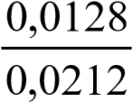 =

= 0,605✓ (4)

6.2 *Aa*

*Cc* =

*At*

(0,027)2

## = 2 ✓✓

(0,032)

= 0,712✓ (3)

6.3 *Qa*  *va* = *At*

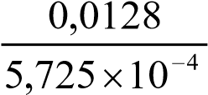 =✓

= 22,358 *ms*/ ✓ *va*

*Cv* = *vt*

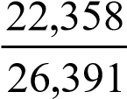 =✓

= 0,847 ✓ (4)

6.4 (*v*2)2  *h*2 =

2*g*

2

22,358

= ✓

2×9,81

= 25,478 *m*✓

*Head loss* = −*h*1 *h*2

= 35,5− 25,478

=10,022 *m*✓ (3)

# [14]

**TOTAL:**  **100**